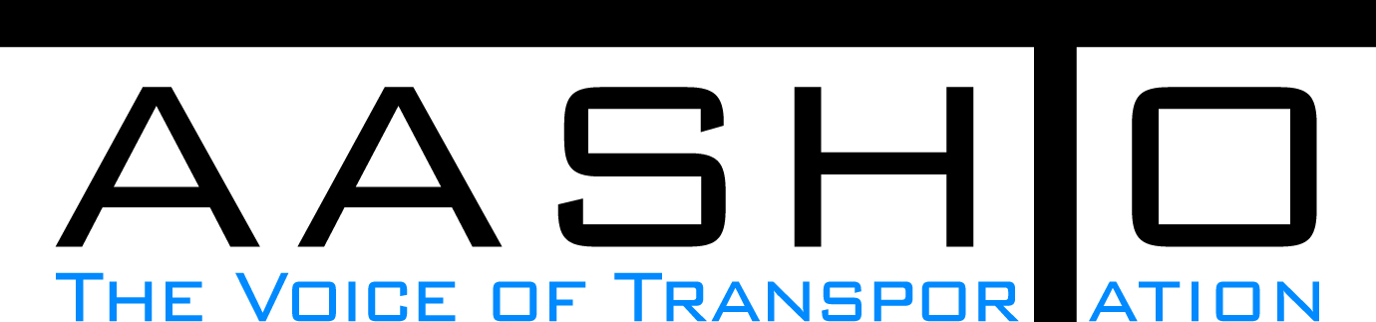Domestic Scan Proposal Form
AASHTO is soliciting topic proposals for a Calendar Year 2015 US Domestic Scan Program (NCHRP Panel 20-68A). Each selected scan topic will be investigated through site visits to three to six locations for approximately a two week period or less (type 1), by webinar, (type 2) peer exchange, or (type 3) conducted by a group of eight to 12 transportation professionals with expertise in the selected topic area. Proposed topics should meet the following criteria:
- Address an important and timely need for information by transportation agencies;
- Are of interest to a broad national spectrum of people and agencies;
- Are complex and also “hands-on,” meaning they lend themselves particularly well to exploration through on-site visits; and
- Are sufficiently focused that the tour participants are able to investigate and understand key issues in the limited time available on the tour.

Before submitting your proposal it is highly recommended that you read What Makes a Good Scan Topic Proposal http://www.domesticscan.org/what-makes-a-good-scan-topic-proposal
This form is designed to collect the full length of your proposal. Sections requiring essays have unlimited space for you to use. Contact information has some limited text. Use your TAB→ key to advance to the area where you need to complete information.
Proposals should be returned no later than OCTOBER 15, 2014.
IMPORTANT NOTE on How to save your document: LastNameFirst Initial, underscore_Organization Acronym _CY2015.
Saved Document Name Example: VitaleM_AASHTO_CY2015
If you have more than one, add a number after first initial: VitaleM1_AASHTO_CY2015

Domestic Scan Proposal Contact Information
Name | JEFFREY A. POULIOTTE | Address | 605 Suwannee Street, MS-52  Tallahassee, FL 32399-0450
Title | State Structures Maintenance Engineer | E-mail | jeffery.pouliotte@dot.state.fl.us
Member Department | Florida | Telephone number | (850) 410-5691
AASHTO Committee | SCOBS T-9 and T-18, SCOM Bridge Technical Working Group, TSP2 National Bridge Preservation Partnership (NBPP) Coatings Group, NBPP (MWBPP, NEBPP, SEBPP and WBPP), and TRB Bridge Preservation Committee | Date of submission | 10/6/2014

Title of Proposed Scan: Bridge Recoating Best Practices

Problem Statement (What topic is to be examined? What drives the need for the scan? Why now?)
As of December 2013, there were 607,751 bridges in the U.S. national bridge inventory, and 181,095 of those bridges have steel superstructures. Recoating existing steel bridges is a large and costly part of state transportation agency needs. Many agencies are dissatisfied with the service life of recoating projects, and are faced with significant challenges in balancing available resources with major rehabilitation, reconstruction and complete replacement needs due largely to corrosion. According to a study by NACE titled: “Corrosion Cost and Preventive Strategies,” the annual direct cost of corrosion for highway bridges is estimated to be $6.43 billion to $10.15 billion. Improvements in this area are essential in order to protect our national investments in infrastructure and to extend the service life of our nation’s bridges. Such improvement strategies will result in significant cost savings by reducing the need for recoating, and delaying costly major rehabilitation and replacement activities. This proposed scan will facilitate the collection and dissemination of effective strategies and best practices used by State Departments of Transportation and other highway agencies. Some of the focus areas of the proposed scan will include but not be limited to coating option decision making, surface preparation, specifications for coating systems (including complete removal and replacement of coating, overcoating and spot/zone coating), performance-based contracts, evaluation practices for in situ coatings prior to recoating, evaluation of performance of overcoat and replacement coatings, inspector qualifications, contractor qualifications, resource management, and agency accountability.
This proposed scan topic has been supported by the AASHTO Subcommittee on Bridges and Structures’ (SCOBS) T-9 “Technical Subcommittee for Bridge Preservation” and T-18 “Technical Subcommittee for Bridge Management, Evaluation and Rehabilitation”; AASHTO Subcommittee on Maintenance’s (SCOM) Technical Bridge Working Group; TSP2 National Bridge Preservation Partnership’s (NBPP) Midwest Bridge Preservation Partnership (MWBPP), Northeast Bridge Preservation Partnership (NEBPP), Southeast Bridge Preservation Partnership (SEBPP) and Western Bridge Preservation Partnership (WBPP); and the Transportation Research Board’s (TRB) Bridge Preservation Committee.

Scan Scope (What specific subject areas are to be examined? Which cities and states might be visited? Which agencies/organizations (including specific departments or types of staff if applicable)?
Visit selected states or other agencies e.g. toll authorities that have aggressive corrosive environments to coating systems that have had commendable and successful programs, and identify the aspects of recoating practices that lead to success.

Anticipated Scan Results (What key information is to be gained? What information is to be shared after the scan? Who would the audience be for this information?)
The result of the scan will be documented in a report that highlights the significant challenges and successful corrosion mitigation recoating strategies. The report will be shared with AASHTO member states and other bridge owners. The summary of the report and the scan will also be presented nationally through presentations made at various national Venues such as AASHTO SCOBS and SCOM annual meetings, TRB annual meeting, and other webinars targeted for bridge engineers, technicians, and general practitioners.

Benefits Expected (Including potential impacts on current technology or procedures)
Bridge maintenance recoating constitutes a major expenditure for most DOTs. There is a huge potential for this scan to provide specific information and effective strategies for implementation by bridge owners that will result in substantial cost savings and significant extension of service life for bridges.

